RED BLACK TREES
- Romita Pawar
Introduction:
Red-Black trees are self-balancing binary search trees that use a color-coding system to maintain optimal performance. This was introduced by Rudolf Bayer in year 1972 and later refined by Guibas and Sedgewick in 1978, these data structures solve the critical problem of tree imbalance that can severely degrade search performance.

Problem they Solve:
Standard binary search trees can become unbalanced when data is inserted in sorted order, degrading from O(log n) to O(n) performance. Red-Black trees prevent this by enforcing balance constraints through node colouring, guaranteeing that the longest path from root to leaf is at most twice the shortest path.

These maintain a balance through below five fundamental rules:
- Every node is either red or black
- The root node is always black
- Red nodes cannot have red children (no consecutive red nodes)
- All paths from any node to its leaf nodes contain the same number of black nodes
- All leaf nodes (NIL nodes) are considered black

These trees are extensively used in real-world applications including C++ STL maps and sets, Java's TreeMap and TreeSet, and Linux kernel scheduling. Their combination of guaranteed O(log n) performance with relatively simple insertion and deletion algorithms makes them ideal for systems requiring both speed and reliability.

Advantages:
Compared to AVL trees, Red-Black trees require fewer rotations during insertion and deletion, making them more efficient for write-heavy applications. While AVL trees are more strictly balanced, Red-Black trees provide sufficient balance with better practical performance for most use cases.
Red-Black trees represent an elegant solution where simple colouring rules create sophisticated balancing behaviour, demonstrating how well-designed constraints can transform a basic data structure into a powerful, industry-standard tool.

Key Concepts / Process in AlgoVision:
- Path Length: (refers to the number of edges traversed from root to any leaf node)
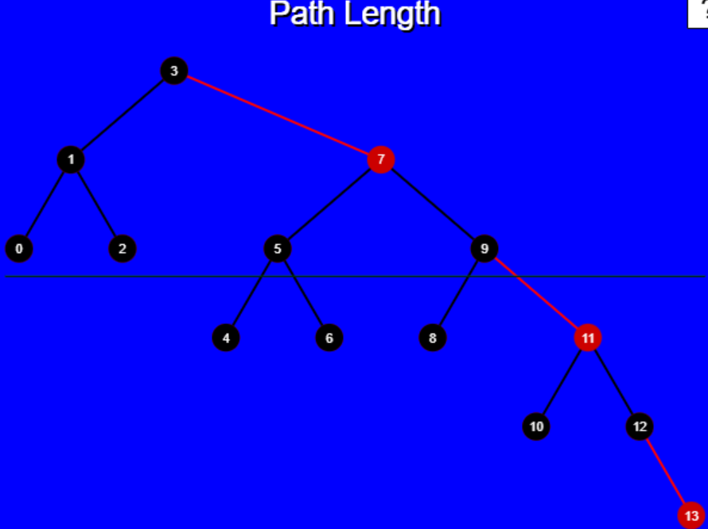
Black height (number of black nodes on any path) remains constant across all root-to-leaf paths. This constraint guarantees O(log n) search time while allowing flexibility in tree structure.

- Color analysis of rotation:
Parent-child color relationships are analyzed to determine if violations exist after structural changes. Color swapping between nodes may be required to restore the red-parent-red-child prohibition.

- Rotation and Moving Black:
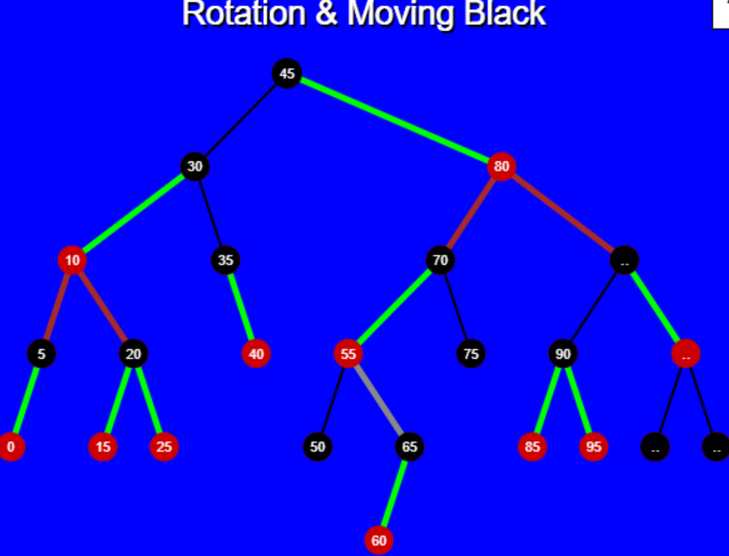
When a black node is rotated, its new position must not create unequal black heights in different subtrees. The process involves careful tracking of black nodes to ensure uniform distribution after rotation. Sometimes additional color changes are needed to compensate for black node redistribution.

- fully black detection:
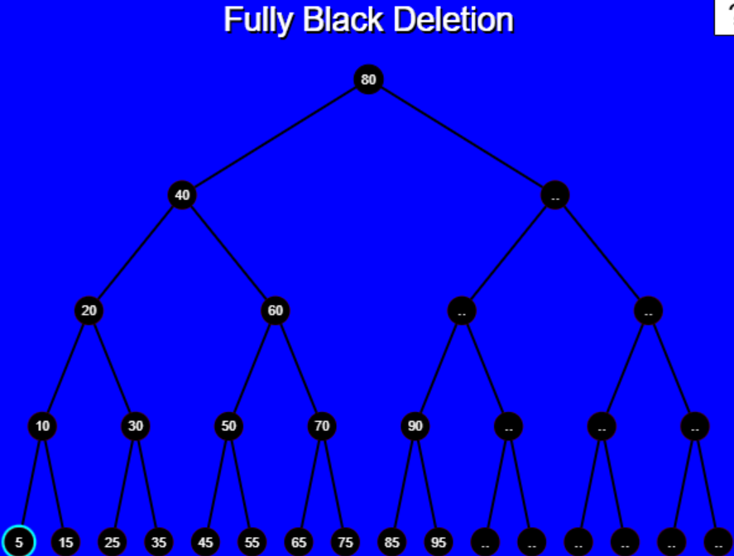
This indicate potential imbalance issues. This condition often arises during deletion operations when black nodes are removed from specific paths. Detection algorithms scan for consecutive black nodes that might violate the balanced black height requirement. Recognition of fully black scenarios triggers specific rebalancing procedures to restore tree properties.

- Doubly black nodes:
Doubly black condition propagates upward until it can be resolved through rotations and re-colouring.

- Red-Black and 2-3-4:
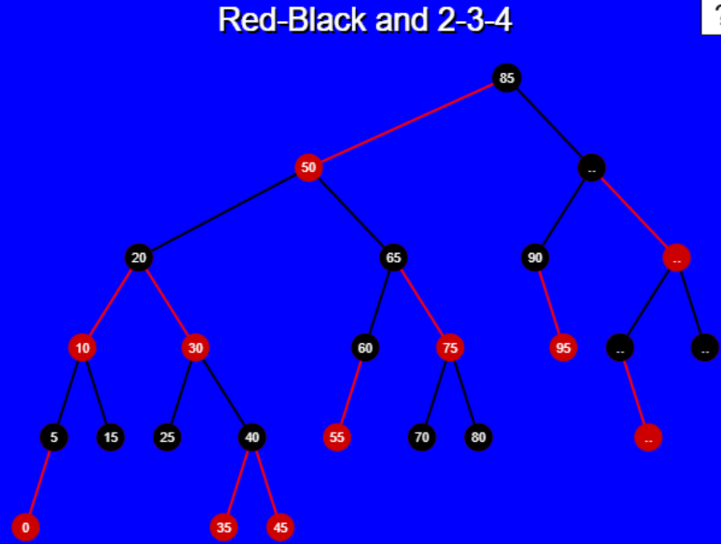
Red-Black trees have a direct correspondence with 2-3-4 trees, where each 2-3-4 node can be represented using Red-Black node combinations. Red nodes with black parents correspond to multi-key nodes in 2-3-4 trees, providing an alternative visualization of the structure. This relationship helps understand why Red-Black trees maintain balance and provides insight into insertion and deletion algorithms.

- RB Tree Rotation:
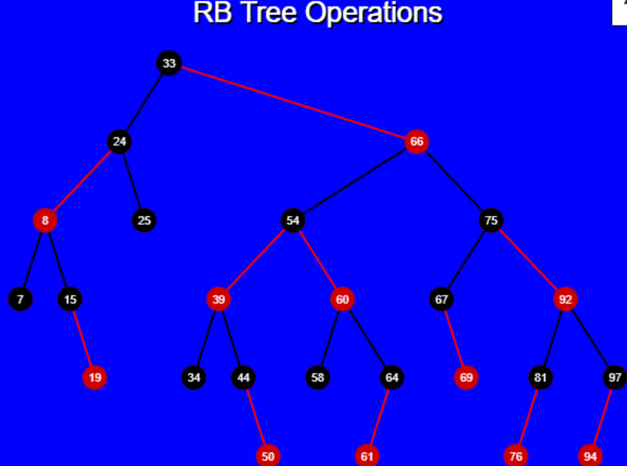
Left and right rotations swap parent-child relationships between nodes, moving subtrees to different positions within the tree. Rotations are typically followed by color adjustments to restore Red-Black properties that may be violated.

Conclusion:
The evaluation of Algovision’s Red Black Trees visualizations reveals several areas of improvement. Moreover, many a times it gives “Paragraph not reachable”. Which is okay, but again it appears at the blue example screen itself. Overall, it has a good enough user-interface. Suggestions to enhance the tool’s will be just to not add this ‘Paragraph’ thing and also, more detailed and on point explanation with clarity and effectiveness, providing users with a more intuitive and comprehensive understanding of Red-Black Trees.

